Agency for
Data Supply and Effciency
Agency for
Data Supply and Effciency

Goals of the Agency

We provide a good basis for decision-making

We must create a real-time picture of our country and
society

We free up time and resources

We must be able to assess where we can create the most value

We create a better digital foundation for growth

It must be easier for users to locate data

Main focus areas

We must ensure that different data can be used in combination

We must be able to create
more value in the administrative procedures of others

Our users must be able to combine the data they require

Danish Agency for
Data Supply and Efficiency
STRATEGY 2020

Opportunities in digitisation Our role

Society is changing more and more rapidly, whilst the demands on the public sector are increasing. This requires us to make quick decisions about how to develop and change society.

When knowledge about society is digitised we are provided with faster and more precise insight into the development of society.

Digitisation thus makes it possible to develop and adjust society at a speed never previous seen.
The task of the Agency for Data Supply and Efficiency is to provide the foundation for political decisions through reliable data which can be combined, and to ensure that geo and administrative data create value across the public sector. The Agency supplies the public sector, citizens and businesses with data, giving them more intelligent and accurate knowledge about society.

We facilitate collaboration across the public sector
The Agency for Data Supply and Efficiency facilitates collaboration across the public sector. This is necessary if we are to deliver the most relevant data about our country and society. The Agency’s capacity to understand the data requirements of others is vital in its ability to identify areas where improved use of public data may benefit the entire society – and what is required to achieve this effect.
The best digital foundation
The Agency for Data Supply and Efficiency provides the best digital foundation
– helping the public and private sector use data to create better solutions for the citizens and economic growth in society.

We provide a good basis for decision-making
Our main task is to provide politicians and the public sector with data, giving them the best possible basis for making decisions, producing legislation and undertaking administrative tasks.

We free up time and resources
In some areas of the public sector, improved use of data may free up time and resources to solve other and more important tasks. We help to recognise and harness this potential.

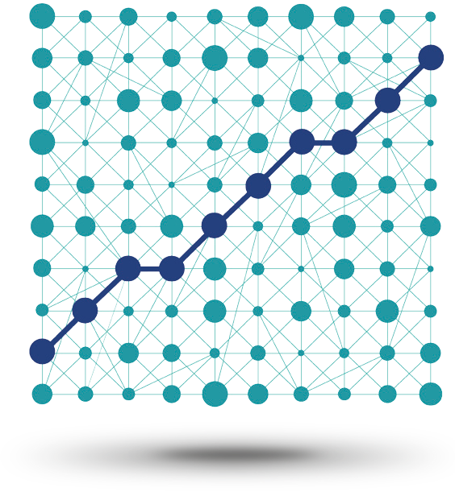

We create a better digital foundation for growth
The digital infrastructure shall facilitate economic growth. We aim to make public data and digital infrastructure easy to use.

Total overview.

Our users should be able to combine the data they require.

We must create a real-time picture of our country and society.

Main focus areas

It must be easier for users to locate data.

We must ensure that different data can be used in combination.

We must be able to assess where we can create the most value.

We must be able to create more value in the administrative procedures of others.

Main focus areas

We must create a
real-time picture of our country and society

An up-to-date picture:
Digitisation helps the public sector get an overview of the national and societal development in real time. Our task is to provide the public sector with an up-to-date picture, which may serve as a basis for public administration.

We must ensure that different data can be used in combination

Combinable data:
We are experts in combining data. It is our responsibility that our data can be used directly within a number of contexts. Therefore, we must create data that can be used in combination with the data of others, regardless of which administration they are relevant for.

We must be able to assess where we can create the most value

New methods:
To create value, it is vital to understand where our work may realise the greatest potential. In the next few years we must develop our competences in order to better assess where our work creates the most value.

We must be able to create more value in the adminis- trative procedures of others

Administration:
Our data must be useful and valuable to politicians and civil servants. We must further develop the work we do across the public sector. The aim is to make an improved data foundation which becomes an inte- grated part of policy development and administration across the sector.

It must be easier for users to locate data

Fewer entry points:
We must make it easier for users to locate data, improving the knowledge on which their work is based. To do this, we must consolidate the existing data entry points and ensure that they provide users with as much value as possible in their work.

Our users must be able to combine the data they require

Flexibility:
Users should be able to combine the data that is relevant to them. This requires flexible entry points that allow users to access various types of data at the same time and create a good user experience.

